HW 12B: Develop a MATLAB program for the transient heat transfer problem you solved in HW 12 for simple finite differences in time. Due Tuesday, July 12.

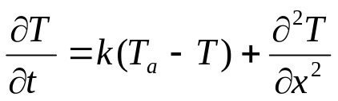

Use the boundary conditions and constants we used in Lecture 12 homework with the zero flux boundary conditions at x=L. The initial condition of T(x) = 20◦C for unknown nodes at t = 0.

Provide print outs of your MATLAB code comparing the RK4 code with Forward Euler for the time derivative with a timestep of 0.05. Provide 2 plots:
- 10 nodes, ∆t=0.05, t=0.05 and time 50 (4 curves on one plot)
- Calculate the relative error comparing the RK4 method with forward Euler (HW 12) at each node at times of 0.05 and 50 and plot together on one plot. (2 curves at one plot).

